**CLQB Average Time Spent Per Page – CA**

**Description:** The graph illustrates the average time spent by users on each page within the Commercial Auto (CA) workflow. The data displayed corresponds to the 90th percentile of user engagement over the last 24 hours, and shows the amount of time users spend on each of the pages.

For instance,

* Users have spent an average of 1.01 seconds on Default page, 3.9 seconds on Drivers page, and so on.
* The unusually long average time spent for page(s), for example, Vehicles page in the graph shown below, is 6.13 seconds, and is highlighted in red.

The ability to switch between percentiles (90th, 50th, 10th, and All) and time periods offers deeper insights into user behavior trends with respect to the engagement variability on different pages.

**Graph Screenshot:**

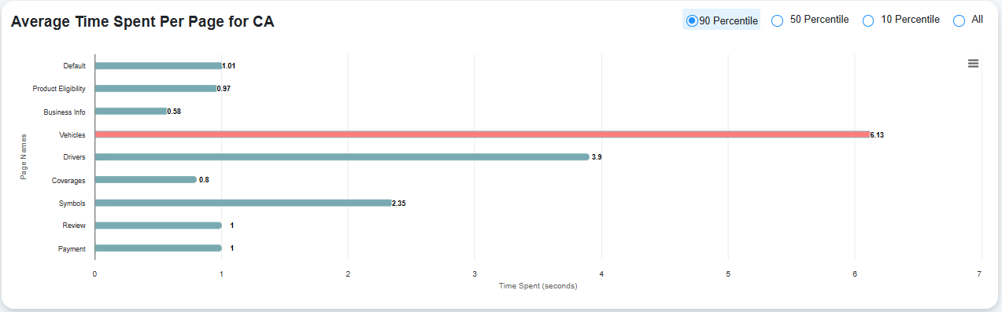

The x-axis shows the average time spent (in seconds) and the y-axis shows the page names.